# TODO API with H2:

## Creation of new todo:

### Postman:

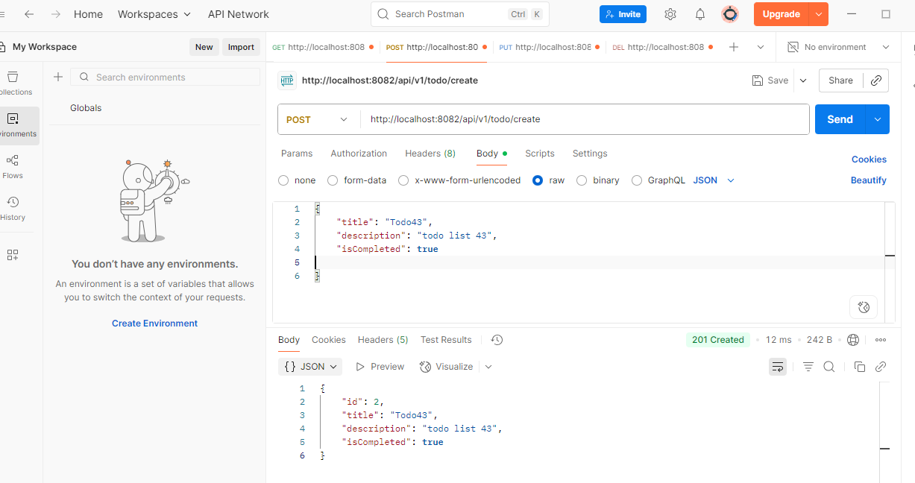

### H2 Screenshot:

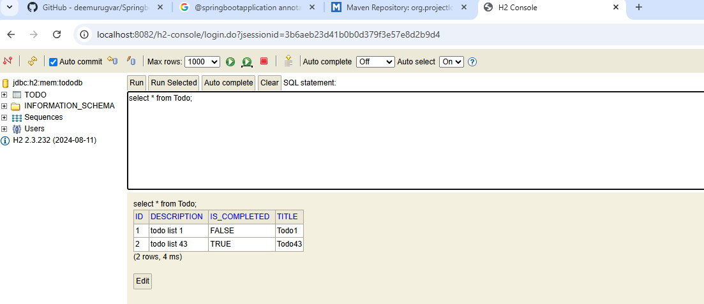

## Retrieving the record by id:

findById is used:

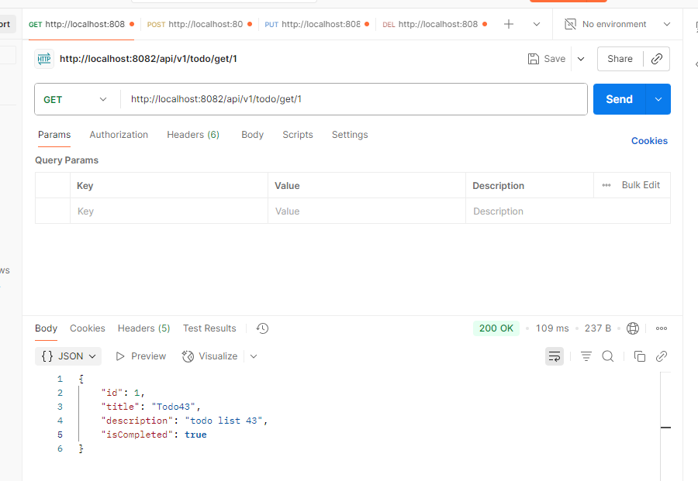

Not found:

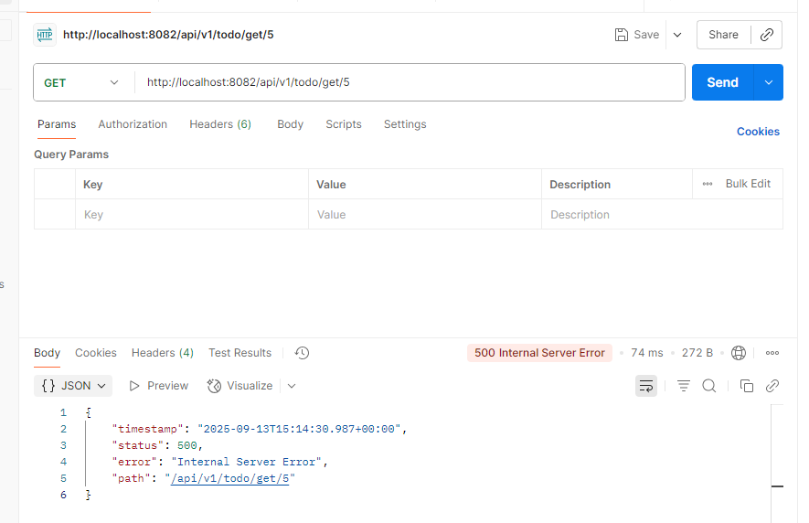

Exception in logs:

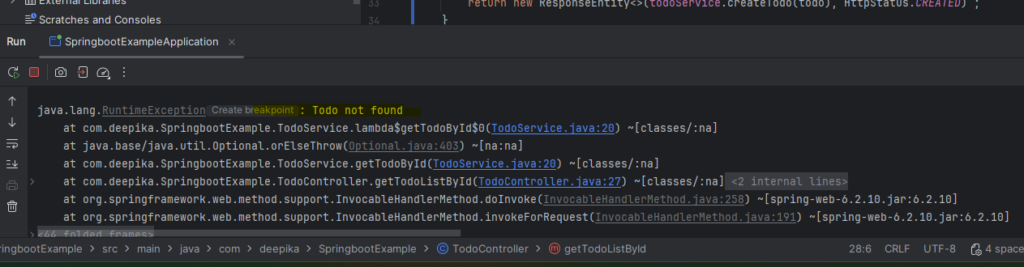

Need to customize the status code to return as 404 in the postman when an exception occurs

## Retrieve all the todo list:

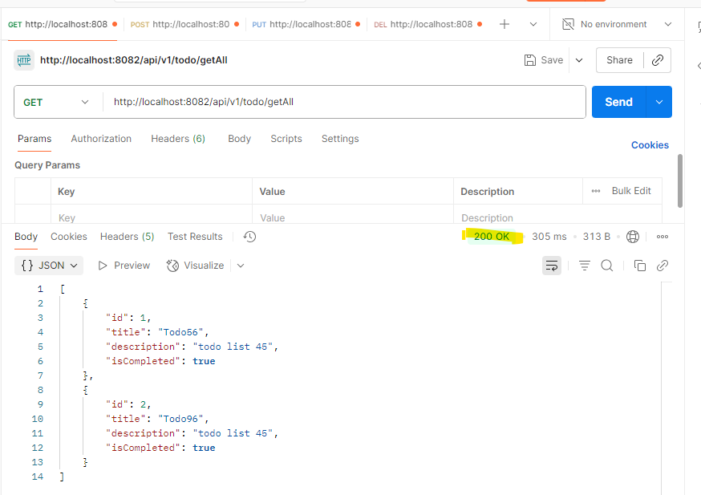

## Delete the record by id:

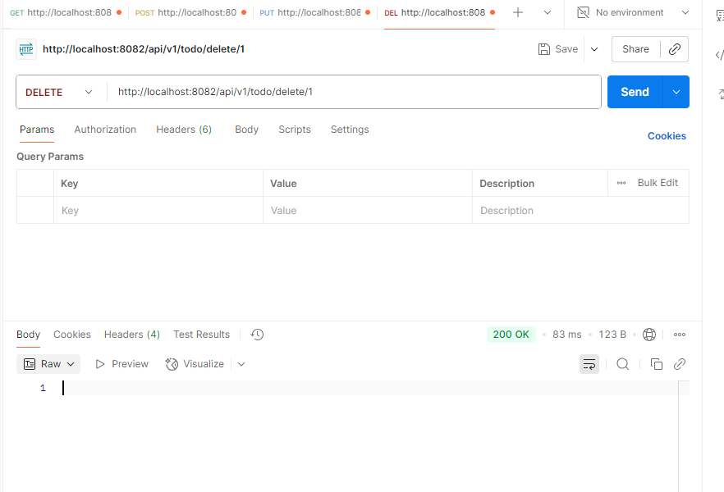

Viewing the records after deletion:

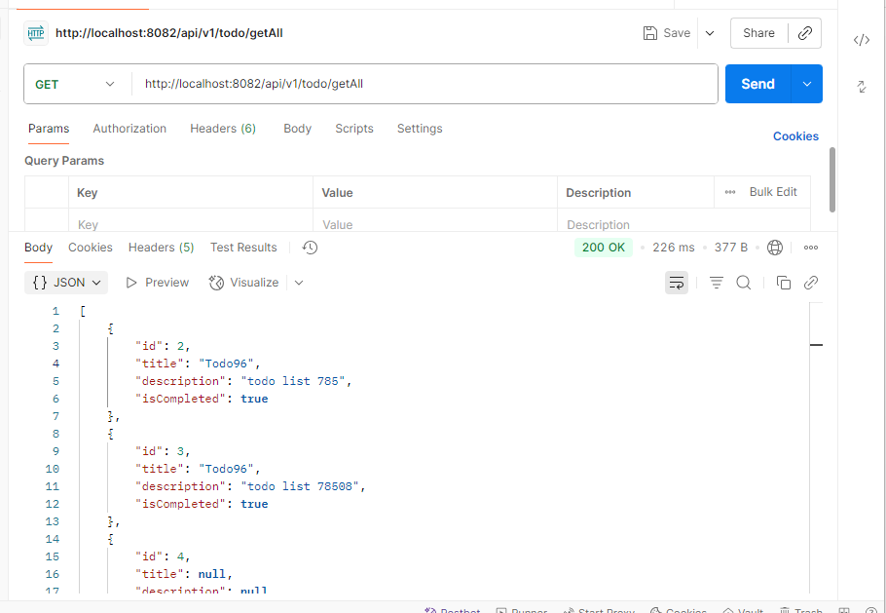

## Updating the record:

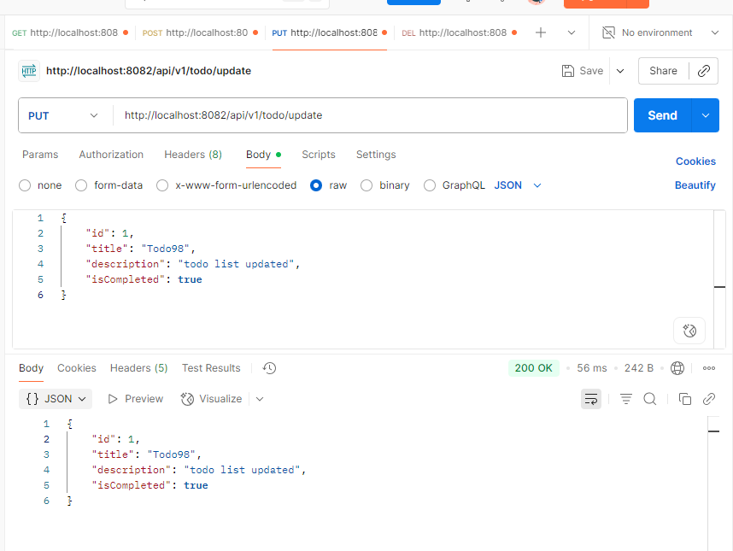

Retrieving post updating:

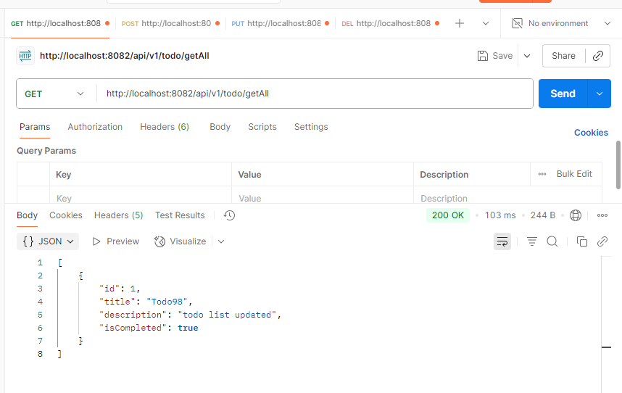

# Connection with PostgresSQL:

Can be achieved by simply adding the db configurations like jpa platform, url, username, name, driver class name. No more changes required. Spring follows convention over configuration approach.

Below is the PostgresSQL config:

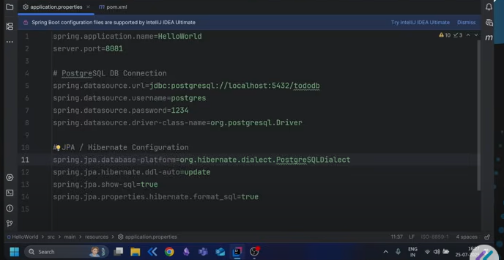

# Swagger:

Undocumented is coming for 500 since we just added the dependency alone and no annotations included. By Default, 200 is documented

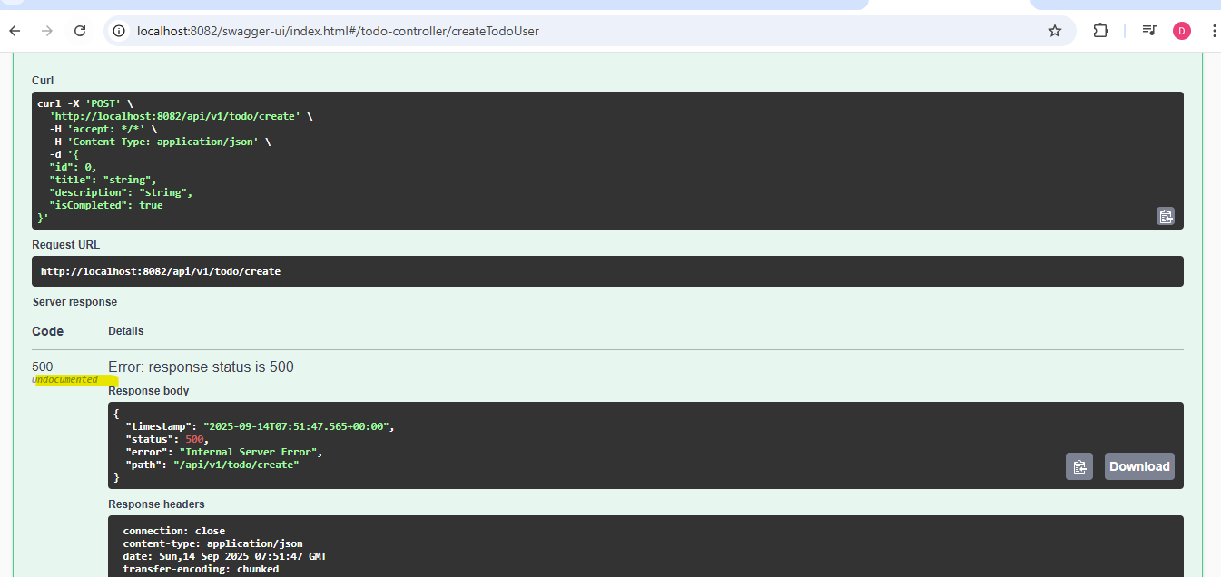

After adding few configurations in Controller class, 500 got documented and displayed the user defined message.

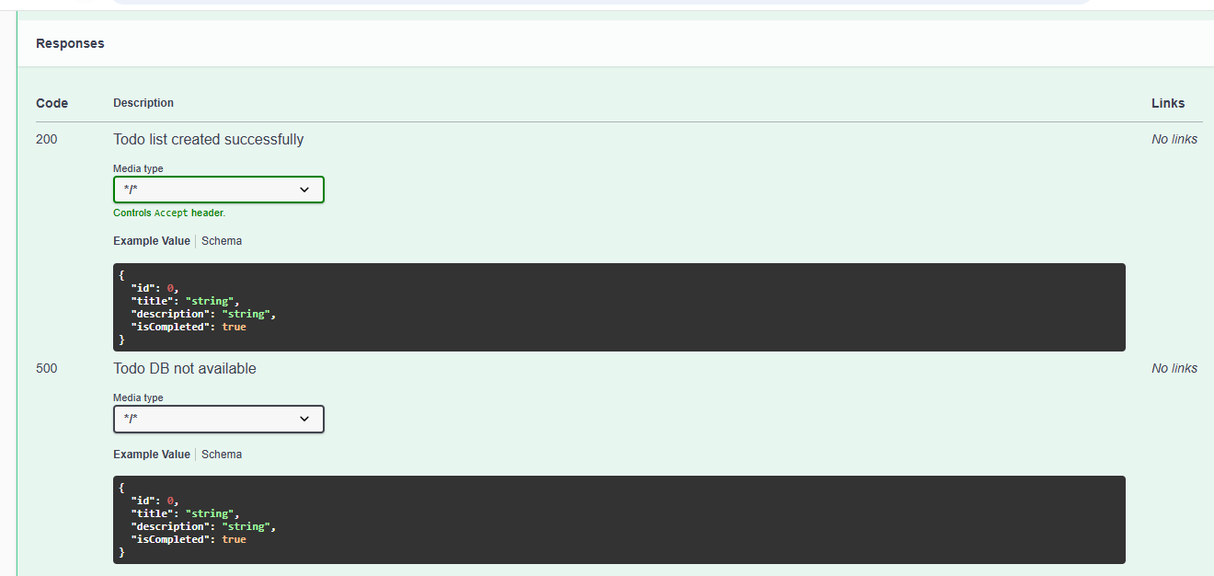

# Spring Security: